Name:________________
Hour:________
Scientific Method Review
Identify the correct part of the Scientific Method.
- I notice that some birds fly in a pattern. ______________________
- Creating a graph from my results. __________________________
- My hypothesis was incorrect. The data showed a 5% increase in gas produced instead of a decrease. This could be due to the weather while testing. ________________________
- If Pea plants get fertilizer, then they will grow taller. _____________________
- I used the Internet to find more information on battery voltage. ___________________________
- Do cars go faster with more horse-power in the engine? __________________
- Testing how light affects plant growth. ________________________
- Identify the INDEPENDENT and DEPENDENT variable. Do plants grow better in blue light? Write a hypothesis that would answer this question.
Independent=
Dependent=
Hypothesis=

- Use the graph to make a conclusion.
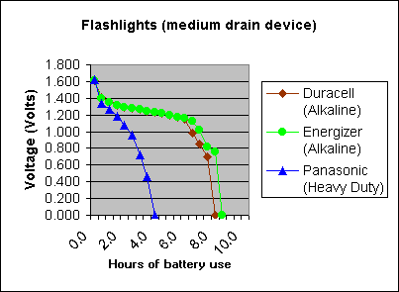

- How is science different than pseudoscience? Explain

Name:________________________Hour:________
Scientific Method QUIZ
Identify the correct part of the Scientific Method.
- _________________________ My hypothesis is correct. Students who drank caffeine before they
went to bed had a difficult time sleeping. The caffeine keeps them 5 minutes longer.
- __________________________I noticed that geese fly in a V-shaped pattern.
- __________________________I created a bar graph showing my results.
- __________________________I used some magazines to take a closer look into my problem.
- __________________________I identified materials and procedure to test if caffeine affects sleep.
- __________________________If sunscreen is used then, then UV rays will be blocked longer.
- __________________________Does HairDini make your hair curly?

- A scientist noticed that the number of salamanders in ponds in the Rocky Mountains was declining. This was a(n)
a. hypothesis b. theory c. observation d. control
9. Ms. Stocker read an article that claimed that students who are given a one hour nap everyday from 9 am – 10 am will 4.0 all of their classes. She decides to test this theory and allows the ninth and tenth graders to use the gym for rest time. Juniors and seniors must continue to attend all classes. This new schedule is enforced for one semester and the difference in each student’s grade point average is analyzed.
Control Group: _______________________________ Experimental Group:_______________________

Independent Variable: _________________________ Dependent Variable: _______________________

10.Identify the INDEPENDENT and DEPENDENT variable. Does fertilizer make grass greener?

Independent Variable: _______________________ Dependent Variable: _______________________

Write a hypothesis to answer the question:

11.What are the TWO main differences between science and pseudoscience?

12.Use the graph to make a conclusion.

