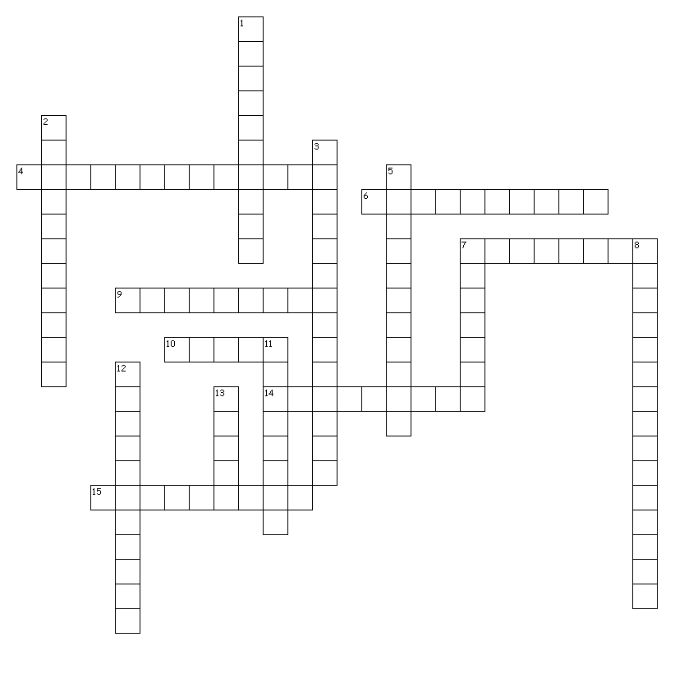
DNA and Mutations

Across
4. Process in which mRNA is synthesized from the template DNA in the nucleus
6. Mutation where a single nitrogen base is added or deleted from the DNA code
7. Permanent change in a cell’s DNA
9. Type of RNA that associates with proteins to form ribosomes and assists in protein synthesis
10. Mutation where a single nitrogen base in a codon is changed
14. Three nucleotide sequence complementary to the codon on mRNA
15. Type of RNA that carries genetic information from DNA in the nucleus to direct protein synthesis in the cytoplasm

Down
1. Subunit of nucleic acid formed from a simple sugar, a phosphate group and a nitrogen base
2. Mutation that occurs when gene distribution in gametes during meiosis changes
3. Process in which DNA is copied in Interphase
5. Process in which mRNA attaches to the ribosome and a protein is assembled
7. Any substance, such as a chemical, that causes mutation or increase in rate of mutation
8. Adenine, Thymine, Cytosine, and Guanine, Thymine
11. Type of RNA that transports amino acids to the ribosome to assemble protein
12. Twisted ladder shape of DNA, formed by two nucleotide strands twisted around each other published by Watson and Crick
13. Three nucleotide base code in DNA or RNA

