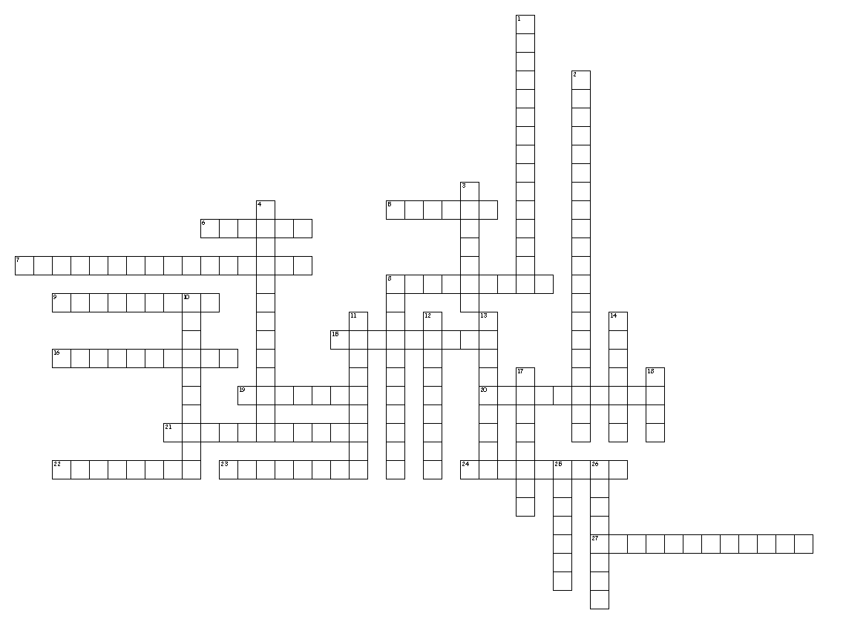
Cell Division
Across
5. Uncontrolled growth and division of cells that can be caused by changes in control of the cell cycle and also may be caused by environmental factors.
6. A haploid sex cell, formed during meiosis, that can combine with another haploid sex cell and produce a diploid fertilized egg.
7. Structure made of spindle fibers, centrioles and aster fibers that is involved in moving and organizing chromosomes before the cell divides.
8. Enzymes that control the cell cycle
9. Programmed cell death.
15. Last stage of mitosis where nucleoli reappear. New nuclear membranes begin to form, but the cell has not yet completely divided.
16. Cell structure that joins two sister chromatids.
19. 2nd main stage of the cell cycle during which the cell's replicated DNA divides and 2 genetically identical diploid daughter cells are produced.
20. DNA containing structure that carries genetic material from one generation to another.
21. Anything known to cause cancer
22. 3rd stage of mitosis, sister chromatids are pulled apart and microtubules move the chromosomes to opposite poles of the cell.
23. Pairing up, lining up, and separating of homologous chromosomes in four stages (prophase I, metaphase I, anaphase I, telophase I)
24. 2nd phase of mitosis in which motor proteins pull sister chromatids to the cell's equator.
27. Exchange of chromosomal segments between a pair of homologous chromosomes during prophase I of meiosis.

Down
1. Structure that contains identical DNA copies and is formed during DNA replication.
2. One of 2 paired chromosomes (1 from ea. parent) that carries genes for a specific trait at the same location.
3. Reduction division process, occurring only in reproductive cells, in which 1 diploid (2n) cell produces 4 haploid (n) cells that are not genetically identical.
4. Process by which haploid gametes combine, forming a diploid cell with 2n chromosomes, with one set (n) of chromosomes from each parent
8. 3rd main stage of the cell cycle, during which the cell's cytoplasm divides, creating a new cell.
10. 1st stage of the cell cycle, during which a cell grows, matures and replicates its DNA.
11. Occurs after meiosis I, separating sister chromatids (identical to mitosis) in four stages (prophase II, metaphase II, anaphase II, telophase II)
12. Relaxed (string) form of DNA in the nucleus of a cell.
13. The process of cellular reproduction, occurring in 3 main stages—interphase (growth), mitosis (nuclear division) & cytokinesis (cytoplasm division).
14. Cells with 2 copies of each chromosome (2n). (skin cells, muscle cells, body cells, etc)
17. 1st stage of mitosis, during which the cell's chromatin condenses into chromosomes.
18. Functional unit of DNA that controls inherited trait expression that is passed on from one generation to another.
25. Cell with half the number of chromosomes (n) (gametes, egg, sperm, etc)
26. Unspecialized cell that can develop into a specialized cell under the right conditions

