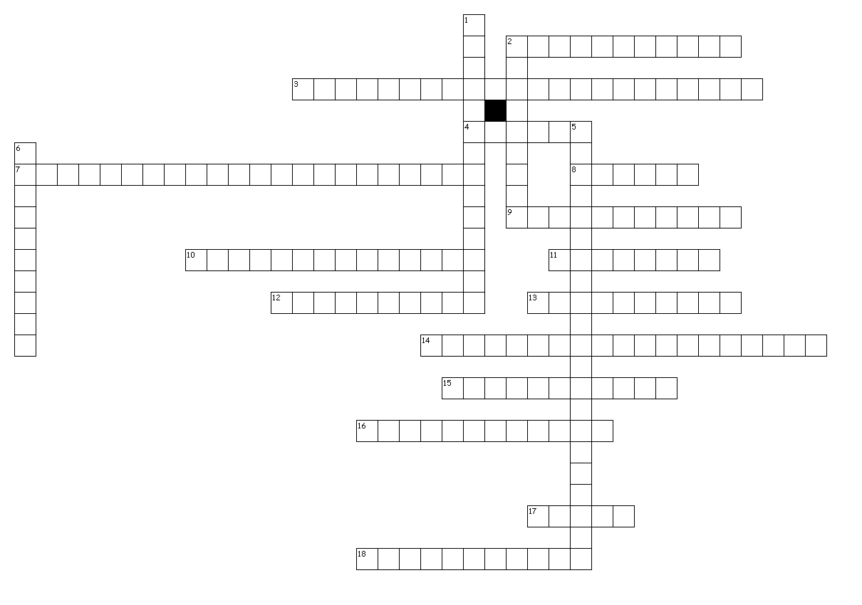
Cellular Energy
Across
2. metabolic process that requires oxygen
3. final step of aerobic cellular respiration where oxygen is used to create 32 ATP
4. the fluid filled space outside the grana where the Calvin Cycle/Light independent reaction of photosynthesis takes place
7. first step of photosynthesis where sunlight and water are used to produce oxygen
8. the ability to do work
9. pigment in chloroplast that is used to trap sunlight in photosynthesis
10. energy cannot be created or destroyed; energy is converted to different forms
11. light-absorbing molecules found in the thylakoids
12. flattened, saclike membranes arranged in stacks where the light dependent reactions of photosynthesis takes place
13. the breakdown of pyruvate into carbon dioxide releasing further energy
14. the catabolic pathway in which organic molecules (glucose) are broken down to release ATP energy for the cell
15. the organelle in which photosynthesis takes place
16. process that occurs after Glycolysis when NO oxygen is available, occurs in the cytoplasm to regenerate NAD+ for Glycolysis
17. stacks of thylakoids
18. light-independent reactions where carbon dioxide is used to produce glucose

Down
1. the anabolic pathway in which light energy from the sun is converted into chemical energy (food) for the cell
2. any metabolic process that does not require oxygen
5. a biological molecule that provides the basic unit of chemical energy
6. the process of breaking down glucose to produce ATP and pyruvic acid (pyruvate)

