Cell Part Location Function Cell Type Picture
Plasma/Cell Membrane | Lipid bi-layer found at the exterior of Cell | Selectively allows material in or out of the cell | Plant, Animal, Bacteria | 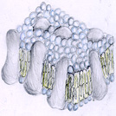
Cell Wall | Rigid Protein that surrounds plasma membrane | Give structure and protection to cell | Plant and some bacteria | 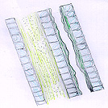
DNA | Compound that Chromosomes are made of in the Nucleus | Pass on genetic information which controls all cell processes | Plant, Animal, Bacteria | 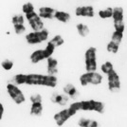
Cytoplasm | Jelly like material that fills interior of cell | Gives support and structure, allows movement of materials throughout cell | Plant, Animal, Bacteria | Picture not available – goo inside cell!
Endoplasmic Reticulum | Folded Membrane throughout the cell with or without small bumps | Smooth and Rough versions help facilitate movement of proteins through the cell and out of it | Plant and Animal | 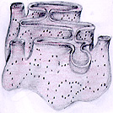
Chloroplast | Round bean shaped structure in cytoplasm | Photosynthesis takes place here due to energy harnessing chlorophyll pigment in these structures | Plant | 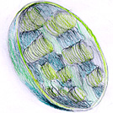
Mitochondrion | Sausage shaped/Kidney bean shaped structure in cytoplasm | Energy-producing chemical reactions take place here  Controls level of water and other materials in cell  Recycles and decomposes proteins, fats, and carbohydrates, and forms urea | Plant and Animal | 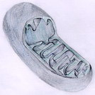
Flagella | Extension of cell membrane | One or two tail–like projections that aid in movement of the cell | Bacteria | 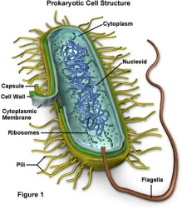
Golgi Apparatus | Sack like membrane found throughout cell | Sac like membrane packages protein for shipping in the cell and out of the cell | Plant and Animal | 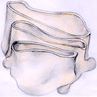
Ribosome | Floating in cytoplasm or the Endoplasmic Reticulum | Sites for Protein Production and distribution | Plant, Animal, Bacteria | 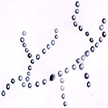
Cilia | External part of cell | Senses cell signals and allows cell to move | Animal | 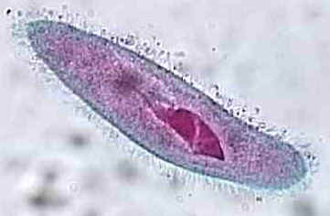
Nucleus | Large membrane bound sphere that contains genetic material | Controls all cell processes | Plant and Animal | 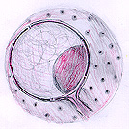
Vacuole | One large sac in Plants or several small in animals | Membrane-bound sacs for storage, digestion, and waste removal  Contains water solution | Plant (very Large) and Animal (small) | 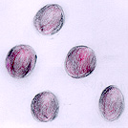
Capsule | Exterior of Cell | Used to protect cell from phagocytosis and infection by viruses | Bacteria | 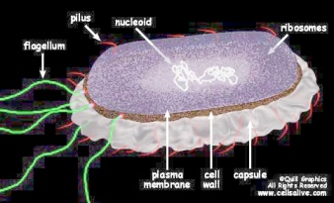
Centrioles | Tubule structures found in Cytoplasm | Aid in cell division | Animal | 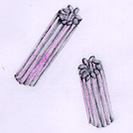
Nucleolus | Ball of material inside of Nucleus | Contains RNA for protein manufacture | Plant and Animal | 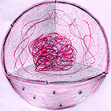
Lysosome | Small packets found throughout cytoplasm | Digests proteins, lipids, and carbohydrates  Transports undigested material to cell membrane for removal | Plant and Animal | 